10Nihar Ramesh Bhandary

200929168

Experiment 4

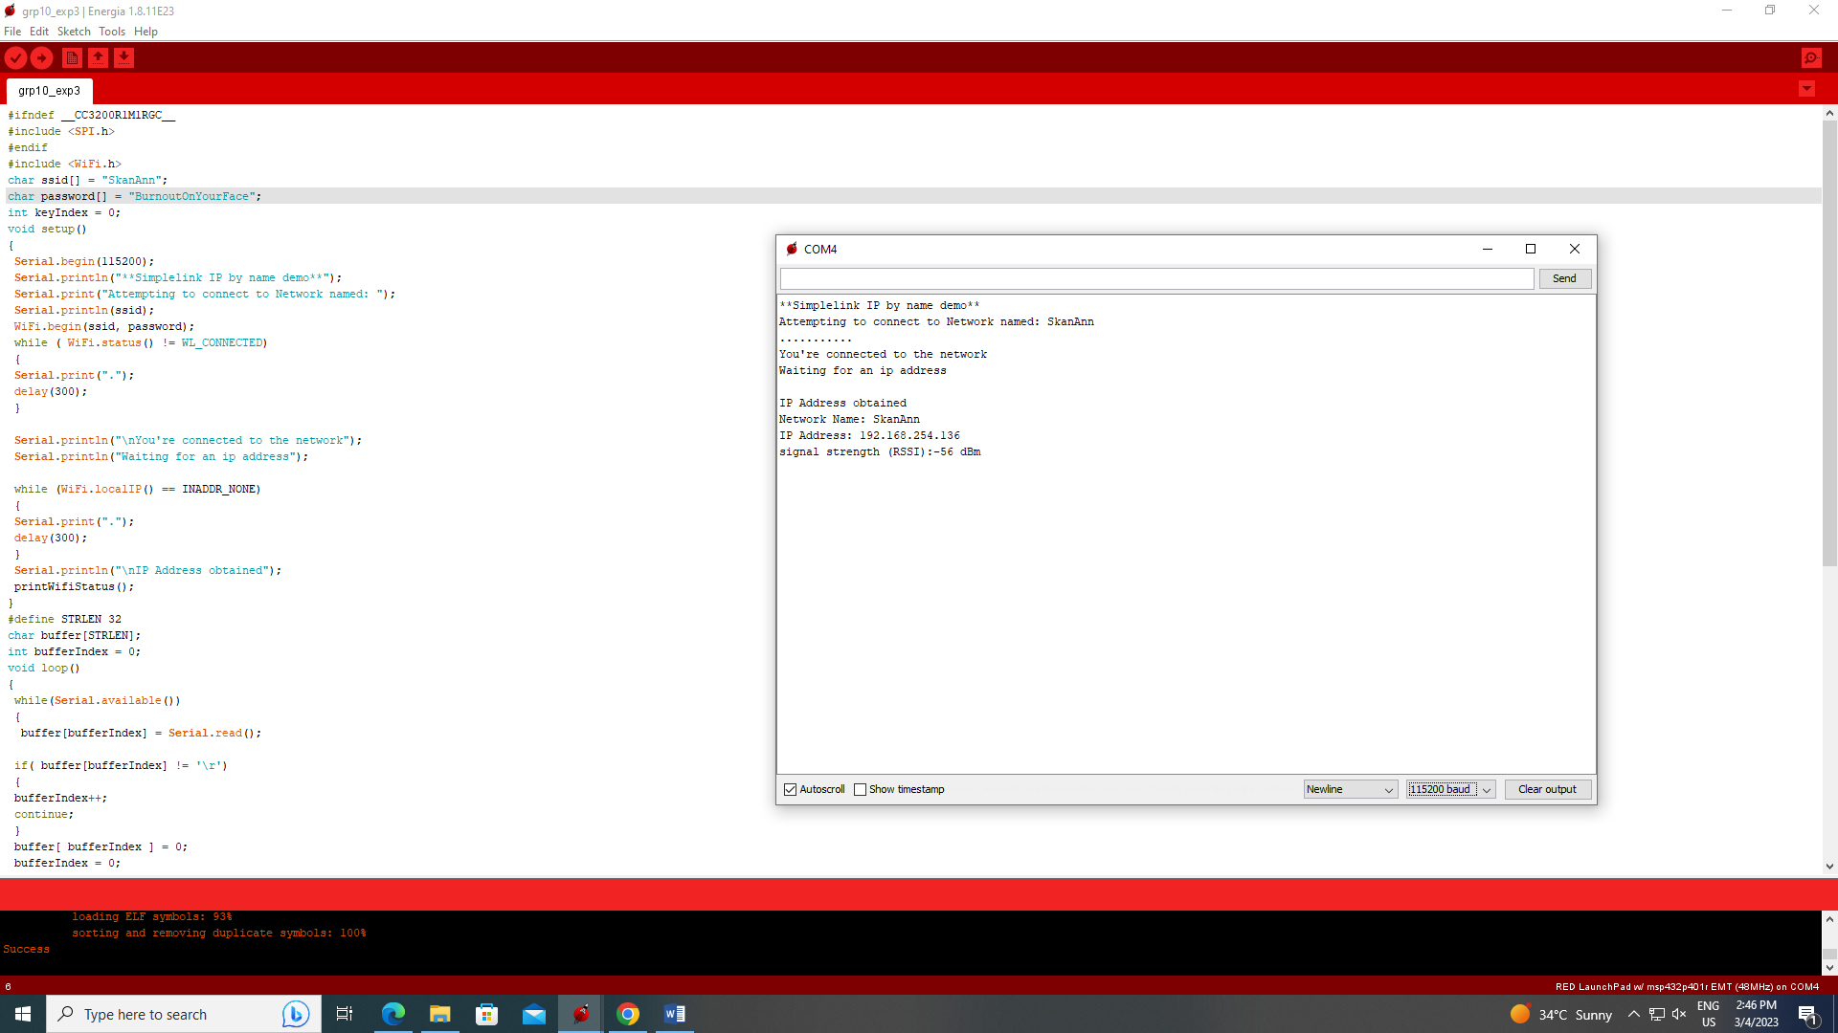

#include <SPI.h>  
#include <WiFi.h>  
char ssid[] = "SkanAnn";  
char password[] ="BurnoutOnYourFace";  
char b[100];  
uint16_t port =5555; // port number of the server  
IPAddress server(192,168,254,116); // IP Address of the server  
WiFiClient client;  
void setup()  
{  
Serial.begin(9600);   
WiFi.begin(ssid, password);  
while(WiFi.status()!=WL_CONNECTED)  
{  
Serial.println("Waiting for Wi-Fi Connection");  
Serial.print(".");  
delay(300);  
pinMode(RED_LED, OUTPUT);  
pinMode(GREEN_LED, OUTPUT);  
pinMode(BLUE_LED, OUTPUT);  
}  
  
Serial.println("WiFi Connected");  
Serial.println("Attempting to connect to Server");  
  
while(!client.connect(server,port));  
Serial.println("Connected to Server");  
}  
void loop()  
{  
if(client.available()) //Checks for any incoming data from server  
{  
char c=client.read();  
Serial.print(c);  
//Serial.println(c);  
if(c ==('W'))  
{  
  Serial.println("BLUE");  
  digitalWrite(BLUE_LED,HIGH);  
  digitalWrite(RED_LED,HIGH);  
  digitalWrite(GREEN_LED,LOW);  
  delay(5000);  
}  
else if(c == 'X')  
{  
  Serial.println("RED");  
  digitalWrite(RED_LED,HIGH);  
  digitalWrite(BLUE_LED,LOW);  
  digitalWrite(GREEN_LED,LOW);  
  delay(1000);  
}  
else if(c ==('R'))  
{  
  Serial.println("GREEN");  
  digitalWrite(GREEN_LED,HIGH);  
  digitalWrite(RED_LED,LOW);  
  digitalWrite(BLUE_LED,LOW);  
  delay(1000);  
}  
else{  
  Serial.println("ELSE");  
  digitalWrite(GREEN_LED,LOW);  
  digitalWrite(RED_LED,LOW);  
  digitalWrite(BLUE_LED,LOW);  
}  
}   
if(Serial.available())  
{   
memset(b,0,100);  
Serial.readBytes(b,100);  
Serial.println(b);  
client.println(b);  
delay(500);  
}  
}

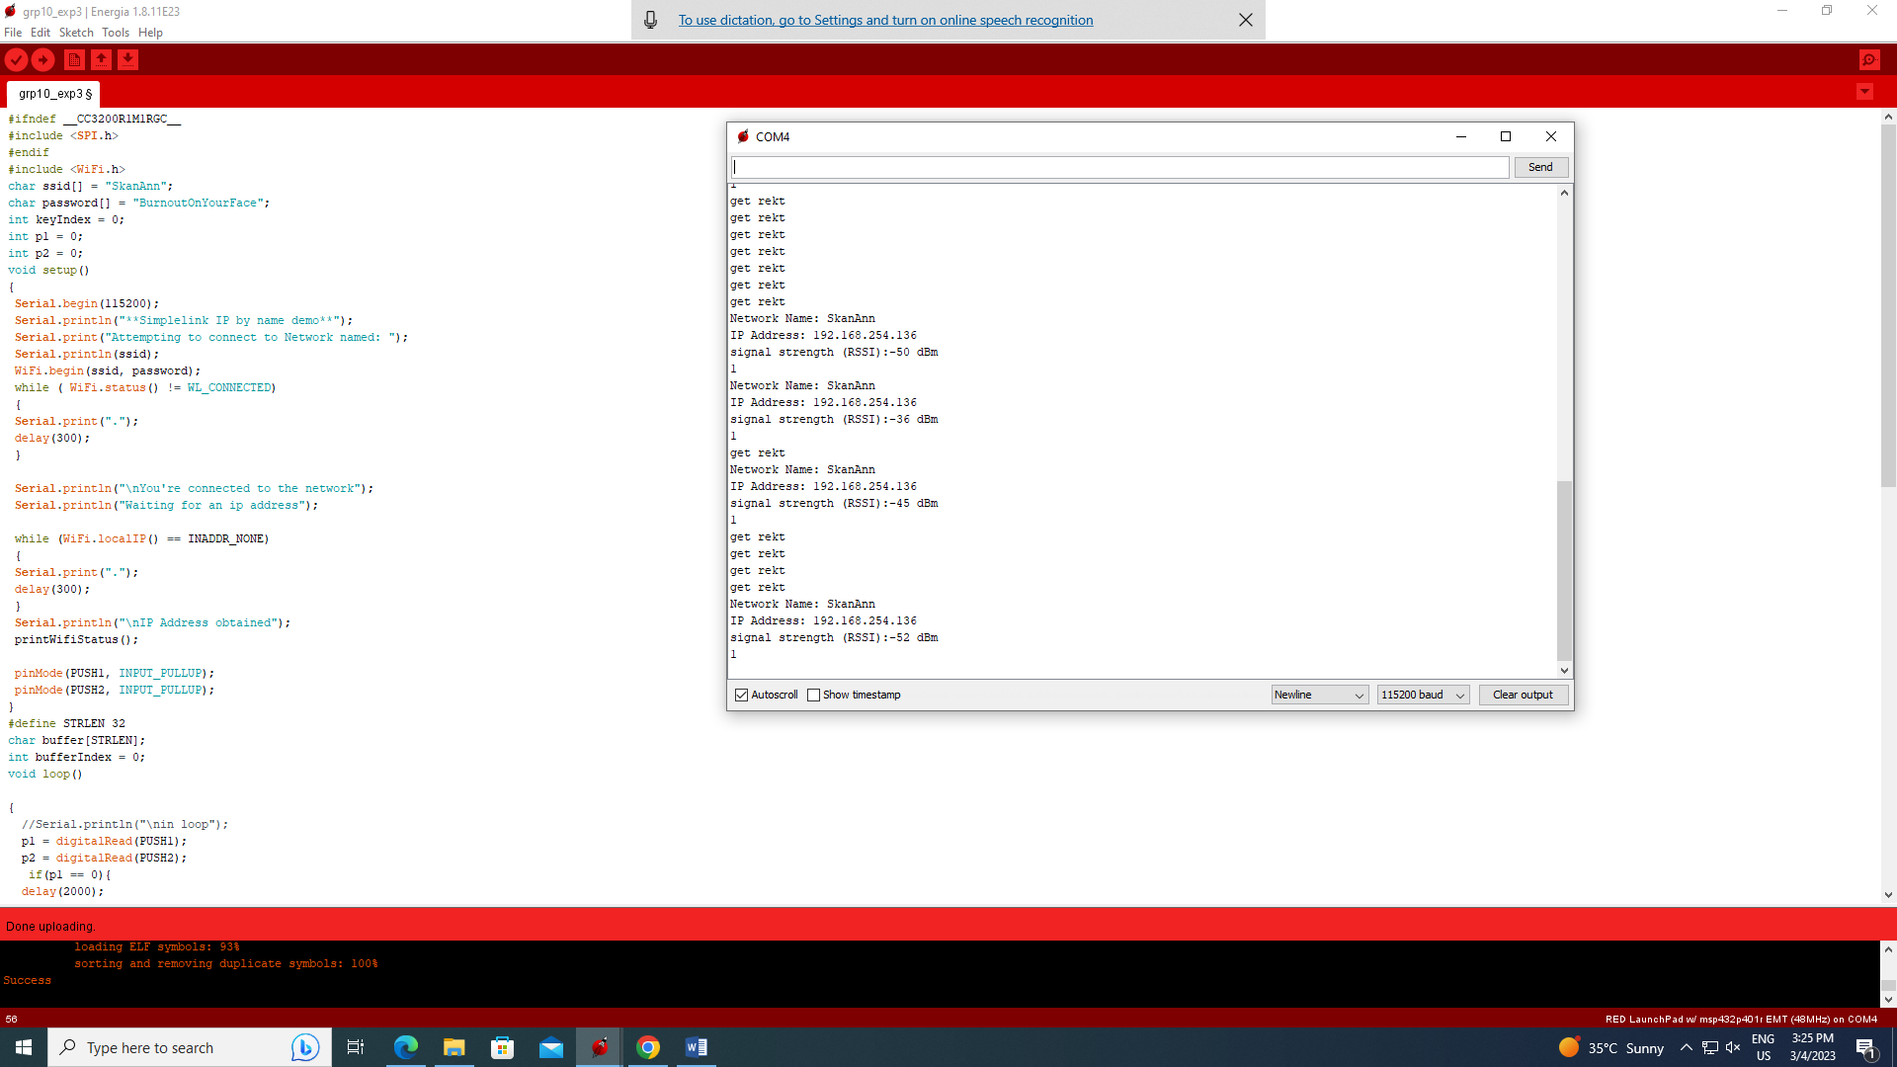 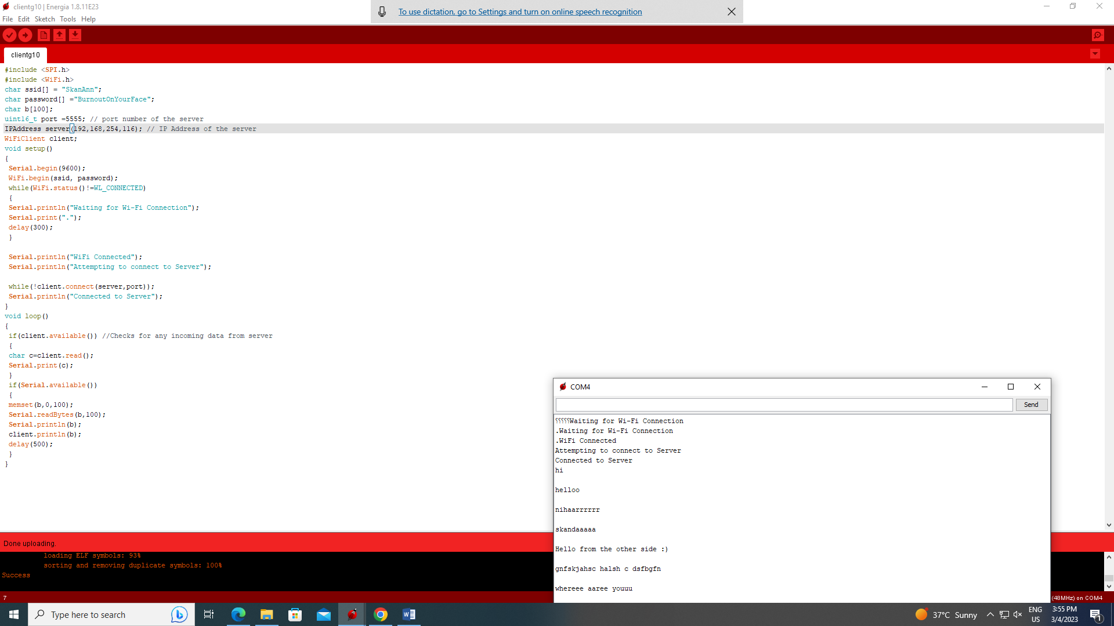

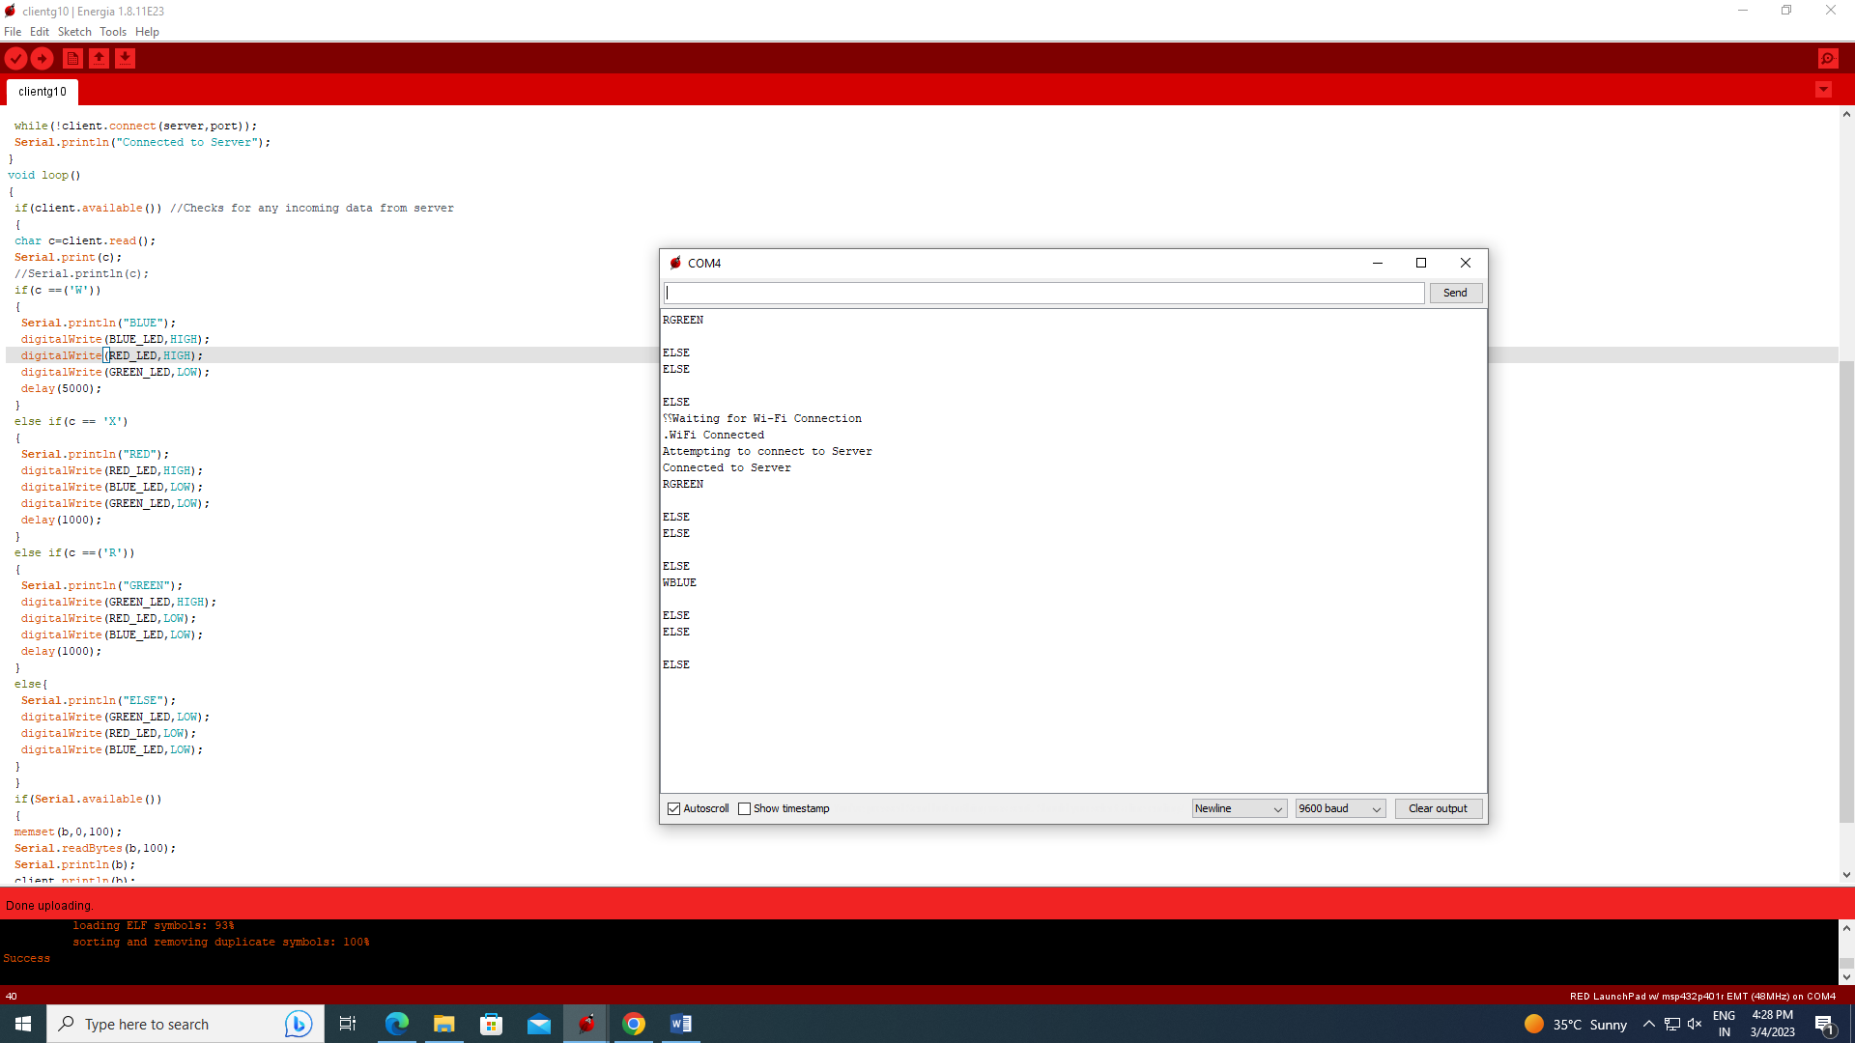

[Saturday 16:31] SKANDA ANNADANA - 200929184

#ifndef __CC3200R1M1RGC__  
#include <SPI.h>  
#endif  
#include <WiFi.h>  
char ssid[] = "SkanAnn";  
char password[] = "BurnoutOnYourFace";  
int keyIndex = 0;  
int p1 = 0;  
int p2 = 0;  
void setup()  
{  
Serial.begin(115200);  
Serial.println("**Simplelink IP by name demo**");  
Serial.print("Attempting to connect to Network named: ");  
Serial.println(ssid);   
WiFi.begin(ssid, password);  
while ( WiFi.status() != WL_CONNECTED)   
{  
Serial.print(".");  
delay(300);  
}  
  
Serial.println("\nYou're connected to the network");  
Serial.println("Waiting for an ip address");  
  
while (WiFi.localIP() == INADDR_NONE)   
{  
Serial.print(".");  
delay(300);  
}  
Serial.println("\nIP Address obtained");  
printWifiStatus();

pinMode(PUSH1, INPUT_PULLUP);  
pinMode(PUSH2, INPUT_PULLUP);  
}  
#define STRLEN 32  
char buffer[STRLEN];  
int bufferIndex = 0;   
void loop()

{  
  //Serial.println("\nin loop");  
  p1 = digitalRead(PUSH1);  
  p2 = digitalRead(PUSH2);  
   if(p1 == 0){  
  delay(2000);  
  printWifiStatus();  
  Serial.println("1");  
}  
if(p2==0){  
  delay(500);  
  WiFi.disconnect();  
  Serial.println("get rekt");  
}  
  
while(Serial.available())   
{  
  //Serial.println("\nin while");  
  buffer[bufferIndex] = Serial.read();  
  
if( buffer[bufferIndex] != '\r')  
{  
bufferIndex++;  
continue;  
}  
buffer[ bufferIndex ] = 0;   
bufferIndex = 0;   
Serial.print("Getting IP for ");  
Serial.println(buffer);  
  
IPAddress IP(0,0,0,0);  
  
int iRet = WiFi.hostByName(buffer, IP);  
if(iRet < 0)  
{  
Serial.println("Host name lookup failed");  
}   
else   
{  
Serial.println(IP);  
Serial.flush();  
}  
}  
}  
void printWifiStatus()   
{  
Serial.print("Network Name: ");  
Serial.println(WiFi.SSID());  
IPAddress ip = WiFi.localIP();  
Serial.print("IP Address: ");  
Serial.println(ip);  
long rssi = WiFi.RSSI();  
Serial.print("signal strength (RSSI):");  
Serial.print(rssi);  
Serial.println(" dBm");  
}